Buyback Types: Buyback Types allows you to load eligible buyback types from CNH in order to use them in buyback processing.

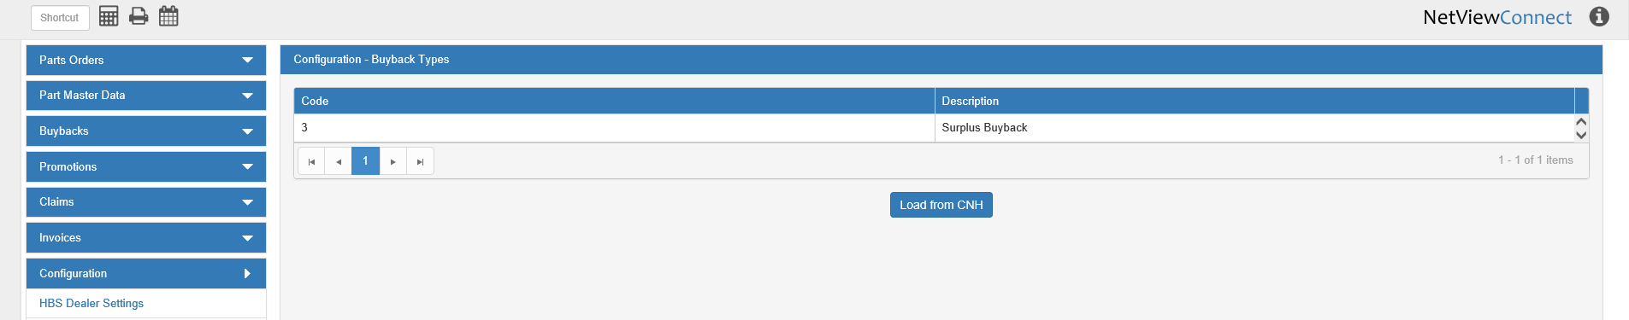

Code: This column shows the CNH buyback type code.

Description: This column holds the type description. The example above is a “Surplus” buyback.

Load from CNH: When you first open CNH Connect (CSPS), you will need to load the buyback types list from CNH, or you will not be able to process your buybacks correctly. After this button is first clicked, the list will automatically reload every 30 days, though you can also click the button at any time to load the most updated version of the list. Note that you will most likely only have one available buyback type.

